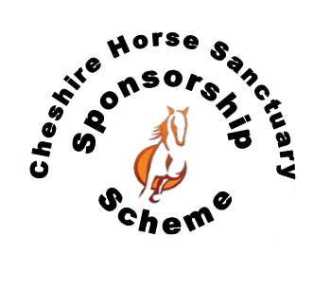FARRIER CARE PACKAGE

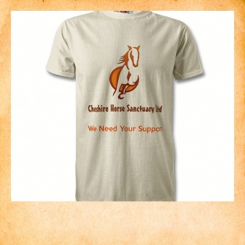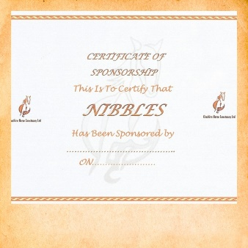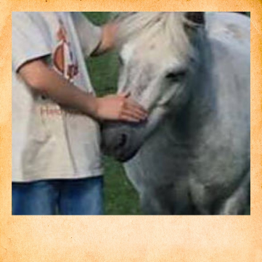

Purchasing the Farrier Care Package means you will support all the Ponies and

Horses in our care.

You will receive a fabulous Sponsorship Pack

* A certificate with your sponsorship
* Lapel pin
* Picture of your pony
* One free visit to spend time with your new friend
* T-shirt with your sponsored pony
* Sponsorship last for 12months

£30

(one off payment)

Unable to keep a horse or pony of your own? Why not make a new friend with one of our sociable herd members?

Horse hoof care is an important issue. Maintaining a healthy hoof is the best way to give horses a good chance at long and healthy lives. This package will go more specifically towards farrier fees.

Your Sponsorship will go directly to supporting our horses and ponies in our care.

You’ll help provide

* **Farrier** – to help maintain healthy hooves
* **Equipment** – to manage their environment
* **Horse clothing** – to help keep them warm
* **Nutrition** – to help feed and give them grazing

Visit our website for more details of how your Sponsorship will provide essential care.

**www.cheshirehorsesanctuary.co.uk/sponsorship**