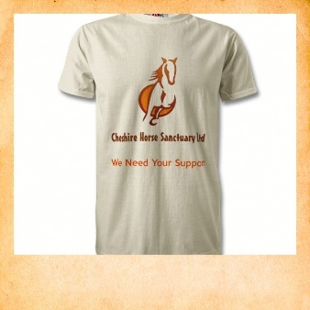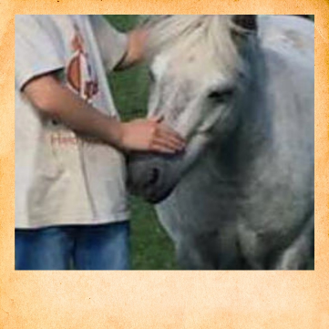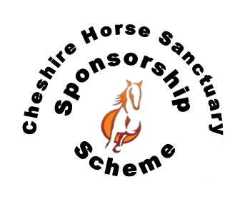

Purchasing the Vet Care Package means you will support all the Ponies and

Horses in our care.

You will receive a fabulous Sponsorship Pack

* A certificate with your sponsorship
* Lapel pin
* Picture of your pony
* T-shirt
* Sponsorship last for 12months
* One interactive learning experience with a friend
* Additional visits can be arranged

(under 16s must be accompanied by an adult)

VET CARE PACKAGE

£70

(one off payment)

Unable to keep a horse or pony of your own? Why not make a new friend with one of our sociable herd members?

In addition to properly feeding and exercising our horses, other aspects of general care are needed to keep our horses healthy. These include routine veterinary care for vaccinations, parasite control, and dental care. This package will help us a lot with all the vet bills we have to maintain healthy and happy horses.

Your Sponsorship will go directly to supporting our horses and ponies in our care.

You’ll help provide

* **Health** - dental care and veterinary support
* **Farrier** – to help maintain healthy hooves
* **Equipment** – to manage their environment
* **Horse clothing** – to help keep them warm
* **Support** – to help feed and give them grazing

Visit our website for more details of how your Sponsorship will provide essential care.

**www.cheshirehorsesanctuary.co.uk/sponsorship**